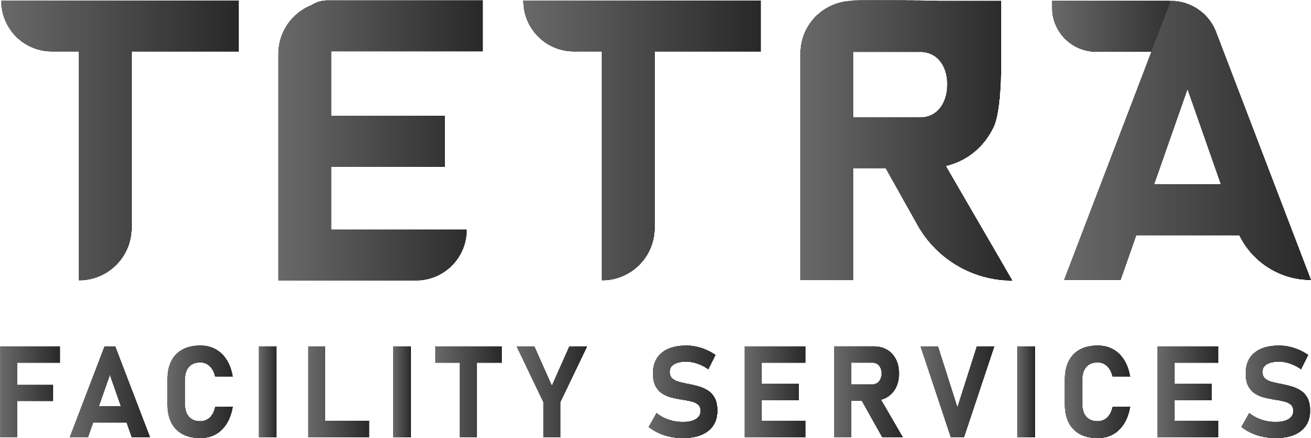
Anti-Bribery and Corruption Policy
Purpose
Tetra Corp is committed to maintaining the highest standards of integrity and ethical conduct in all business dealings. This Anti-Bribery and Corruption Policy outlines our commitment to preventing bribery and corruption in any form, ensuring compliance with Australian laws, including the Commonwealth Criminal Code Act 1995, and international anti-corruption standards.
1. Zero Tolerance for Bribery and Corruption
• Tetra Corp maintains a zero-tolerance approach to bribery and corruption. We prohibit all forms of bribery, including the offering, giving, receiving, or soliciting of anything of value to influence a business decision or gain an unfair advantage.
• This policy applies to all employees, contractors, suppliers, and business partners, regardless of location or role within the organization.
2. Compliance with Laws and Regulations
• We are committed to complying with all applicable anti-bribery and corruption laws and regulations, including the Commonwealth Criminal Code Act 1995 and the Australian Anti Money Laundering and Counter-Terrorism Financing Act 2006.
• Employees, contractors, and partners are expected to adhere to these legal requirements and uphold the integrity of Tetra Corp in all business dealings.
3. Gifts and Hospitality
• Tetra Corp recognizes that the exchange of modest gifts and hospitality can be part of normal business relationships. However, such exchanges must be transparent, reasonable, and not intended to influence or reward a business decision.
• All employees must declare and seek approval for any gifts or hospitality that exceed a predetermined value or could be perceived as compromising the integrity of our business operations.
4. Facilitation Payments
• Facilitation payments, also known as "grease payments," are small, unofficial payments made to expedite routine government actions. Tetra Corp prohibits the use of facilitation payments in any form.
• Employees and contractors are required to report any requests for facilitation payments to management, and such requests will be addressed in line with our zero-tolerance policy.
Perth | Western Australia 0450 944 223 www.tetracorp-fs.com.au ABN – 61 670 989
5. Political Contributions and Charitable Donations
• Tetra Corp does not make political contributions to any parties, candidates, or campaigns, as this could be seen as an attempt to gain an improper business advantage.
• Charitable donations are permitted, provided they are made transparently and are not used to conceal bribery or corruption. All donations must be approved by senior management and recorded in the company's financial records.
6. Due Diligence and Third-Party Relationships
• Tetra Corp conducts thorough due diligence on all third-party partners, including suppliers, contractors, and agents, to ensure they share our commitment to preventing bribery and corruption.
• We expect our partners to adhere to the same high ethical standards, and we include anti bribery and corruption clauses in our contracts to enforce compliance.
7. Reporting and Whistleblower Protection
• Employees, contractors, and third parties are encouraged to report any suspicions or incidents of bribery, corruption, or other unethical behaviour. Tetra Corp provides a confidential reporting mechanism for these concerns.
• We are committed to protecting whistleblowers from retaliation and will take appropriate action to investigate all reports of bribery or corruption in a fair and timely manner.
8. Training and Awareness
• Tetra Corp provides regular training and resources to employees and management to ensure they understand their responsibilities under this policy and can identify and prevent potential bribery or corruption risks.
• Ongoing awareness programs are conducted to reinforce the importance of ethical conduct in all aspects of our business.
9. Continuous Monitoring and Improvement
• We are committed to regularly reviewing and improving our anti-bribery and corruption practices to ensure they remain effective and aligned with legal requirements and industry best practices.
• Internal audits and risk assessments are conducted to monitor compliance with this policy and identify any areas for improvement.
10. Consequences of Non-Compliance
Non-compliance with this policy may result in disciplinary action, including termination of employment or contracts. Tetra Corp will not hesitate to report illegal activities to the appropriate authorities when necessary.
Perth | Western Australia 0450 944 223 www.tetracorp-fs.com.au ABN – 61 670 989

We are committed to upholding our reputation for integrity and will take all necessary steps to ensure our business operations are free from bribery and corruption.
Acknowledgment
By engaging with Tetra Corp, employees, contractors, and partners agree to comply with this Anti Bribery and Corruption Policy and commit to maintaining the highest standards of ethical conduct in all business dealings.
Perth | Western Australia 0450 944 223 www.tetracorp-fs.com.au ABN – 61 670 989

